Doc No: BCIM/HYD/MS/ LH10/06
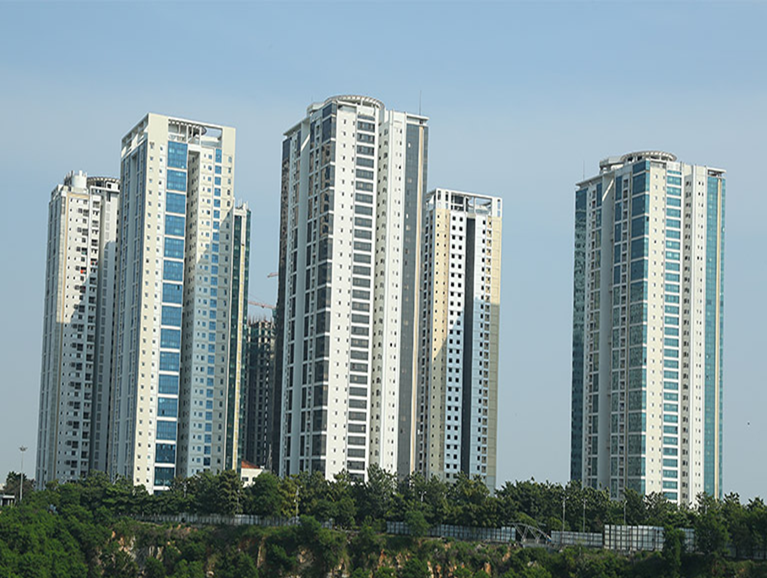
Project Name |  | LANCO HILLS RESIDENTIAL PROJECT- LH 10 ,HYDERABAD
Client |  | LANCO HILLS TECHNOLOGY PARK PRIVATE LIMITED
PMC |  | SAVILLS PROPERTY SERVICES (INDIA) PRIVATE LIMITED
Main Contractor |  | BCIM ENGINEERING PVT LIMITED
REVISION HISTORY
REV.NO | DATE |  | DETAILS OF REVISION
R0 | 21.05.2026 |  | Initial Issue for review and approval
R1 | 29.05.2026 |  | Groove Thickness, Coverage, Pond duration
PREPARED BY  BCIM |  |  | REVIEWED BY  BCIM | REVIEWED & APPROVED BY  PMC/Client

1. TERRACE WATERPROOFING
- Objective

The Objective of this Method statement is to carryout Waterproofing Treatment for Terrace locations by meeting the contract documents, Technical Data Sheet and Approved Drawings.

- Scope of Work
Providing and applying waterproofing for Terrace areas by surface method. The work comprises treating all cracks, construction joints and surface defects, followed by applying two coats of Fosroc Brushbond Roofguard Premium solar-reflective elastomeric polyurethane waterproof coating over a primer of Nitoproof WB.

- Reference
    - Approved Drawings
    - Approved Materials

- Materials Used
S.No | Material/Product | Purpose
1 | Fosroc Brushbond Roofguard Premium | Single Component Acrylic-based modified PU elastomeric solar reflective waterproof coating
2 | Fosroc Nitoproof WB | Primer coat (Diluted 1:2 with water)
3 | Fosroc Renderoc CS | Polymer modified cementitious repair mortar for cracks / joints
4 | Cebex 100 (Fosroc) | Grout admixture for pressure grouting @ 225 gms/bag of cement
5 | Fosroc Renderoc Plug | Rapid-setting non-shrink mortar for fixing/sealing PVC nozzles
6 | Fosroc Thioflex 600 | Polysulphide sealant for expansion joints and crack sealing

- System Build-Up
    - Step 1– SurfacePreparation: Crack/joint treatment with Renderoc CS + pressure grouting with Cebex 100
    - Step 2 –Primer Application :Nitoproof WB diluted 1:2 with water @ 8-10 sqm/litre
    - Step 3 – 1st Coat Brushbond Roofguard Premium @ 0.5mm WFT
    - Step 4 – 2nd Coat Brushbond Roofguard Premium @ 0.5mm WFT (Cross direction)

- Surface Preparation & Crack / Joint Treatment
    - Inspect the entire area and identify all cracks, porous zones, construction joints, cold joints , hollow /patch and defective areas.
    - Open all construction joints by providing a 'U' groove using a groove cutter; remove dust and clean the area thoroughly.
    - For individual surface cracks, cut a V-groove of 10 mm wide × 10 mm deep along the crack using a grinder. Clean with compressed air, fill with Fosroc Renderoc CS mortar flush with the surface, and allow to cure before coating
    - Fill the prepared 'U' groove and construction joint areas using Fosroc Renderoc CS repair mortar completely as per manufacturer's instruction
    - For cold joints / construction joints, provide chemical injection pressure grouting: drill 18 mm dia holes, fix PVC nozzles with Renderoc Plug, inject cement slurry mixed with Fosroc Cebex 100 @ 225 gms per bag of cement at required pressure through PVC nozzles
    - After grouting, cut projected nozzles flush and seal off PVC nozzles with Renderoc Plug non-shrink rapid-setting mortar compound
    - Fill all surface hollow portions and surface patches with polymer modified cementitious mortar and allow to cure
    - Clean and degrease the entire surface using wire brush/blower; ensure surface is free of all dust, laitance, oil, and loose matter
Pre-Ponding:
    - Before applying waterproofing, ensure all drain outlets are sealed/plugged. Conduct a pre-application ponding test for 24 hours to identify any active leaks; repair all identified leaks before proceeding.
    - Pre-wet the surface with clean water before application. Surface should be Saturated Surface Dry (SSD)
- Application Procedure – Fosroc Brushbond Roofguard Premium
    - After complete curing of crack/joint repairs, apply primer coat of Fosroc Nitoproof WB: mix base and hardener, then dilute with double the quantity of clean water (ratio 1:2 by volume) to obtain a milky white liquid. Apply using roller or brush at a coverage of 8–10 sqm/litre. Allow primer to dry completely
    - Apply the FIRST coat of Brushbond Roofguard Premium using roller, brush, squeegee, or airless spray at a wet film thickness (WFT) of 0.5 mm per coat at a coverage of 0.5 litre/sqm (20 sqm per 20-litre pail for 2 coats). Ensure uniform coverage.
    - Allow the first coat to dry for 1–5 hours (depending on climatic conditions) before applying the second coat.
    - Apply the SECOND coat of Brushbond Roofguard Premium at 90° to the first coat at the same thickness and coverage, ensuring a minimum total wet film thickness of 1.0 mm is achieved (resulting in 0.5 mm dry film thickness).
    - Extend the coating to the full height of the parapet wall as per manufacturer's specification.
Post-Ponding / Flood Test:
    - After curing the membrane for a minimum of 72 hours, conduct a flood test by ponding the terrace to a minimum depth of 50 mm of water for 72 hours. Plug all drains and place barriers to contain the water. Check for any seepage or dampness during and after the test. Proceed to the next stage only after satisfactory test results are approved by the Engineer-in-Charge.
    - Allow complete curing for 7 days.
If in Case of Mother Slab: Above Mentioned all points are need to be done.
If in Case of Existed water proofing area: Cracks repair and Brushbond Roofguard Premium Coating Need to be done. (As per BOQ)
Instruments:
    - Grinding Machine with accessories
    - Hammer and Chisel
    - Roller and Paint Brush
    - Drilling machine and bits
    - Injection Grouting Machine
    - Slow Speed Mixer
    - Spatula
    - Coir Cleaning Brush.

ATTACHMENT
- Check list for Waterproofing

